Jeff Jackson
Project 1: Rumors
CECS 622

The Rumors project was an event based program which analyzed the effected percentage of students under the influence of a rumor over a given amount of time.

Results (N=100)
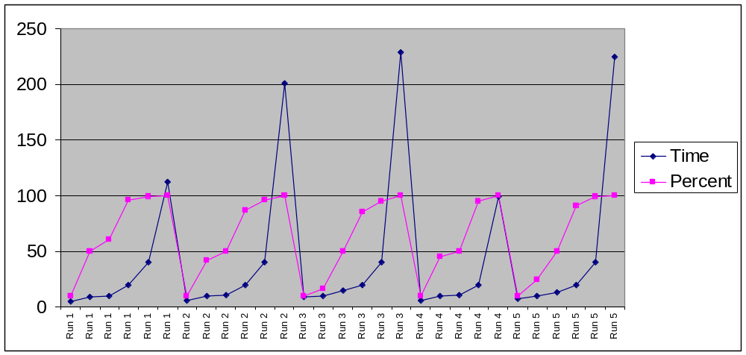

Results (N=1000)
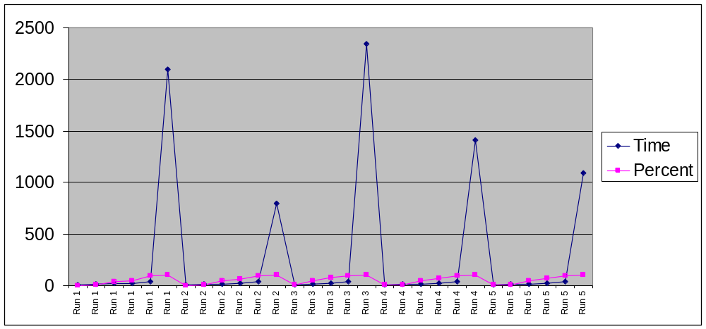

Results (N=10000)
The 100% value was not calculated. The computer never seemed to finish this result, therefore I was not able to include this.
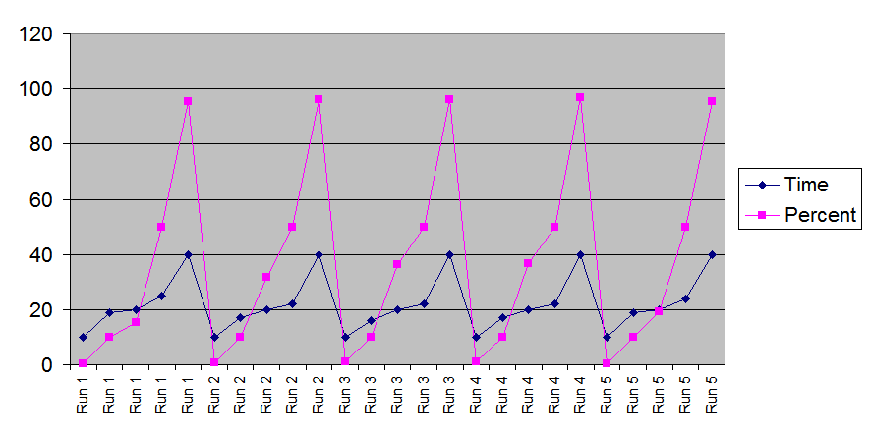

Averages

37.8% of students will have heard the rumor after 10 minutes where N=100.
90.8% of students will have heard the rumor after 20 minutes where N=100.
97.25% of students will have heard the rumor after 40 minutes where N=100.

4.98% of students will have heard the rumor after 10 minutes where N=1000.
63.86% of students will have heard the rumor after 20 minutes where N=1000.
96.68% of students will have heard the rumor after 40 minutes where N=1000.

.698% of students will have heard the rumor after 10 minutes where N=10000.
27.866% of students will have heard the rumor after 20 minutes where N=10000.
96.044% of students will have heard the rumor after 40 minutes where N=10000.

10% Effected

For N=100, 10% of the students were effected at t = 6.6
For N=1000, 10% of the students were effected at t = 13.75
For N=10000, 10% of the students were effected at t = 17.6

50% Effected

For N=100, 10% of the students were effected at t = 11.8
For N=1000, 10% of the students were effected at t = 18.6
For N=10000, 10% of the students were effected at t = 23

Data Set (N=100)
 | Time | Percent
Run 1 | 5 | 10
Run 1 | 9 | 50
Run 1 | 10 | 61
Run 1 | 20 | 96
Run 1 | 40 | 99
Run 1 | 112 | 100
Run 2 | 6 | 10
Run 2 | 10 | 42
Run 2 | 11 | 50
Run 2 | 20 | 87
Run 2 | 40 | 96
Run 2 | 201 | 100
Run 3 | 9 | 10
Run 3 | 10 | 16
Run 3 | 15 | 50
Run 3 | 20 | 85
Run 3 | 40 | 95
Run 3 | 229 | 100
Run 4 | 6 | 10
Run 4 | 10 | 45
Run 4 | 11 | 50
Run 4 | 20 | 95
Run 4 | 99 | 100
Run 5 | 7 | 10
Run 5 | 10 | 25
Run 5 | 13 | 50
Run 5 | 20 | 91
Run 5 | 40 | 99
Run 5 | 225 | 100

Data Set (N=1000)
 | Time | Percent
Run 1 | 10 | 1.3
Run 1 | 17 | 10
Run 1 | 20 | 36.5
Run 1 | 22 | 50
Run 1 | 40 | 96.3
Run 1 | 2092 | 100
Run 2 | 10 | 2.8
Run 2 | 14 | 10
Run 2 | 19 | 50
Run 2 | 20 | 60.7
Run 2 | 40 | 97.2
Run 2 | 799 | 100
Run 3 | 10 | 11.3
Run 3 | 16 | 50
Run 3 | 20 | 82.5
Run 3 | 40 | 97.3
Run 3 | 2343 | 100
Run 4 | 10 | 4.3
Run 4 | 12 | 10
Run 4 | 18 | 50
Run 4 | 20 | 71.4
Run 4 | 40 | 96.2
Run 4 | 1407 | 100
Run 5 | 10 | 5.2
Run 5 | 12 | 10
Run 5 | 18 | 50
Run 5 | 20 | 68.2
Run 5 | 40 | 96.4
Run 5 | 1094 | 100

Data Set (N=10000)
 | Time | Percent
Run 1 | 10 | 0.37
Run 1 | 19 | 10
Run 1 | 20 | 15.42
Run 1 | 25 | 50
Run 1 | 40 | 95.58
Run 2 | 10 | 0.87
Run 2 | 17 | 10
Run 2 | 20 | 31.8
Run 2 | 22 | 50
Run 2 | 40 | 96.12
Run 3 | 10 | 0.92
Run 3 | 16 | 10
Run 3 | 20 | 36.2
Run 3 | 22 | 50
Run 3 | 40 | 96.26
Run 4 | 10 | 0.91
Run 4 | 17 | 10
Run 4 | 20 | 36.68
Run 4 | 22 | 50
Run 4 | 40 | 96.68
Run 5 | 10 | 0.42
Run 5 | 19 | 10
Run 5 | 20 | 19.23
Run 5 | 24 | 50
Run 5 | 40 | 95.58

